Name: ___________________ Date: ___________


Yr 8 Mathematics (General & Ext)
Investigation 2, 2015

Topic – Volume of Prisms- Take Home Section
Important Information:
The take-home component is worth 10 marks, it is essential in preparation for the in-class component. Knowledge and skills gained will be extended in the in-class validation component. This in-class validation will be completed under test conditions on the day in which this take-home component is due. The take-home component may be used when completing the in-class component.

Date out: Week ____ Date _____________ Date Due: Week ____ Date _____________

Weighting: 0% of the year

AIM:
In this assessment, you will be investigating how to calculate volume in prisms. It is important you show all your working to ensure you receive maximum marks.

Volume is a measure of the amount of space an object occupies. The units used in measuring volume are cubic units: mm3, cm3 and m3. The solids on this sheet are all constructed from cubes (each 1 cm3). This allows the volume to be found by counting the cubes with the volume being the total number of cubes (in cm3).
For example
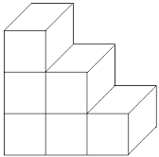

The image above is made up of 6 cubes, so therefore the volume of this shape is 6cm³ V= 6 cm³

1. Using the same methods used above, work out the volume of the following shapes by counting all of the cubes.

a.
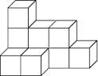 V=

b.
. 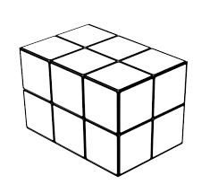 V=

c.
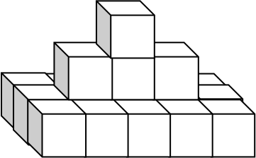 V=

Now lets introduce the Volume formula : V = AH.

Count the number of squares that make up the base area (A) and multiply this by the number of squares that make up the height (H), this will give you the volume in cm3.
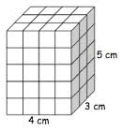
Base area (A) is 4cm x 3cm = 12cm²

Height (H) is 5cm

Volume = 12 x 5
Volume = 60cm³

2. Calculate the volume for the all of the shapes below using the method shown on the previous page.

a.
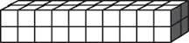

b.
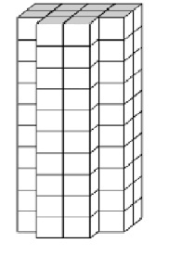
c.
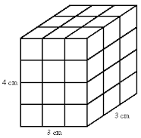
When a solid has a uniform cross section (same shape throughout the height of the solid) then the formula V = AH can be used to obtain the volume of the solid. The area will be given in square units (mm2, cm2, m2) and the height of the solid will be given in mm, cm and m. Multiply the two together to get your answer. The answers will be in cubic units mm3, cm3, m3.

3. Calculate the Volume of the following shapes, the base area is already worked out for you. Use the example to help you.
a.

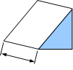

V = AH

A = 36cm² H = 8cm

V = 36 x 8 V= 288cm³
8cm
36cm²

b.

V = AH

A = m² H = m

V = x V= m³

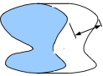
18.3m²
3.5m

c.

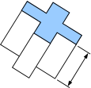
A= 122mm²

V = AH

A = H =

V = x V=
13mm

Rectangular prisms are the most common form of packaging, from shipping containers to match boxes they are everywhere. To calculate their volume you multiply the 3 sides together, in any order. Because we have V = AH as the standard equation for volume with the 'area' part being a rectangle we can replace the A with L × B. So we have V = L × B × H, or V = LBH.

- Calculate the volume of the following rectangular prisms. The first one is done for you.
a.
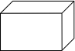
V = AH

A= 8 x 4 A = 32cm²

H = 6cm

V= 32 (A) x 6 (H) V = 192 mm³
6cm
8cm
4cm

b.

7cm
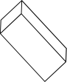
V = AH

A= A = cm²

H = cm

V= (A) x (H) V = cm³
23cm
4cm

c.
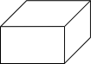
V = AH

A= A =

H =

V= x V = 1071cm³
7mm
17mm
9mm

Triangular Prisms
The method of the sheet is to first calculate the area of the face (uniform cross section area) then multiply it by the height of the shape. Note that because this sheet deals with triangular prisms you must not confuse the h used in A = 1⁄2bh with the H used in V = AH

- Calculate the volume of the following Triangular prisms. The first one is done for you.

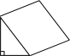
V = AH

A= ½ x B x H A = ½ x 4 x 7

A = 14m²

H = 13m

V= 14 (A) x 13 (H) V = 182m³
13m
7m
4m

b.
V = AH

A= ½ x B x H A = ½ x x

A = cm²

H = cm

V= (A) x (H) V = cm³
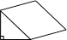
23cm
9cm
6cm

c.
V = AH

A= ½ x B x H A = ½ x x

A =

H =

V= x V =
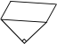
31mm
40mm
15mm

Name: Date: ___________
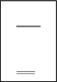

27
%

Yr 8 Mathematics (General & Ext)
Investigation 2, 2015
Topic – Volume of Prisms- In Class Validation
45 minutes
7% of the year. (Take Home & Validation Included)
Penalties (only deducted once in the whole assessment)
- 􏰂 Units - Incorrect/missing (-1)
Important Information:
This investigation will be completed under test conditions. Answers should be rounded appropriately. All working should be shown in the space provided. Solutions without working may not be awarded full marks. Please take the marks for each question into account when answering the question.
AIM:
In this assessment, you will be investigating Volume of Prisms. Make sure you show all your working out and include units.

1. [6 marks: 2,2,2]

Using the counting methods complete the table below

 | Number of cubes | Volume
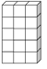

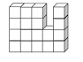

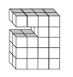

2. [1 mark]

write down the formula to calculate volume for the rectangular prism below

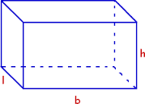

3. [ 1 mark ]

Felicity has a packing box with a base area of 28cm² and the height of the box is 8cm.

What is the Volume of the packing box?

4. [6 marks: 1, 1, 2, 2]

The table below shows the measurements of four different rectangular prisms. Fill in the blank spaces

Length | Breadth | Height | Volume
4cm | 3cm | 4cm
8m | 5m | 2m
3cm |  | 3cm | 27cm
6mm | 2mm |  | 36mm²

5. [3 marks: 1, 2]

a) Draw a rectangular prism with the dimensions 4cm by 3cm by 2cm.

b) Calculate the volume.

6. [6 marks: 2, 2, 2]

Calculate the volume of the triangular prisms below

a)
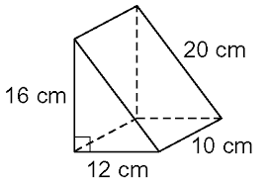

b)

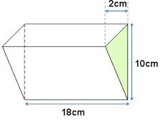

c)
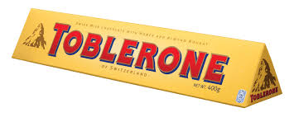
30mm
40mm
200mm

7. [4 marks ]

Calculate the volume of a cylinder drinks can with a radius of 5mm and a height of 110mm.. (HINT: The formula for area of a circle is $π$r².)

Start by making a sketch showing all the informtion.

